Chapter 9: Do You Know How
Potteries are Made?


Tujuh Pembelajaran:

Setelah mempelajari Bab 9, siswa diharapkan mampu:

- Mensyukuri kesempatan dapat mempelajari bahasa Inggris sebagai bahasa pengantar komunikasi International yang diwujudkan dalam semangat belajar.

2.1 Menunjukkan perilaku santun dan peduli dalam melaksanakan komunikasi interpersonal dengan guru dan teman.

2.2 Menunjukkan perilaku jujur, disiplin, percaya diri, dan bertanggung jawab dalam melaksanakan komunikasi transaksional dengan guru dan teman.

2.3 Menunjukkan perilaku tanggung jawab, peduli, kerjasama, dan cinta damai, dalam melaksanakan komunikasi fungsional.

3.6 Menganalisis fungsi sosial, struktur teks, dan unsur kebahasaan pada teks ilmiah berbentuk factual report tentang binatang.

4.9 Menangkap makna dalam teks ilmiah faktual (factual report) lisan dan tulis tentang binatang.

4.10 Menyusun teks ilmiah faktual (factual report) lisan dan tulis tentang binatang dengan memperhatikan fungsi sosial, struktur teks, dan unsur kebahasaan yang benar sesuai konteks.


- Kelas XII SMA/MA/SMK/MAK

A. WARMER: Guessing Games


Let’s play a game. Your teacher will read a

description of something. Please guess, what is being described? Let’s try. Pots, dishes, and other articles made of earthenware or baked clay. What are they? Pottery. Now, please guess in groups. The group that can guess the most is the winner.

- Another name of Iran

- The revival of art and literature in the 14th, 15th and 16th centuries
- The action of making something new

- Having or using images in black, white and shades of grey; black and white
- Allowing light to pass through but not transparent

- Having or using images in many colors

- Decorated with flowers

- A swallow of the Arabian Sea between Iran and the Arabian Peninsula
- An activity to produce something, especially in a big amount
- Making something more beautiful by putting some ornaments to it


Bahasa Inggris | 133

B. OBSERVING AND QUESTIONING

Reading

Task 1: Read the following text about Persian pottery.

PERSIAN POTTERY
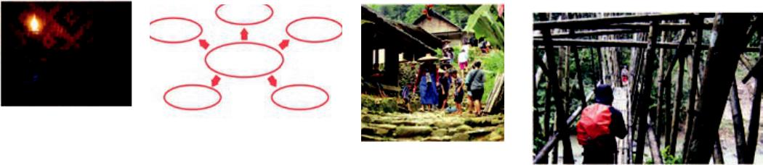

Source: futureofflight.org

Picture 9.1 Persian Pottery

Pottery is one of the oldest and most widespread of the decorative arts, consisting chiefly of functional objects (such as vessels, plates, and bowls) made of clay and hardened with heat. Earthenware is the oldest and simplest form; stoneware is fired at a high temperature to cause it to vitrify and harden; and porcelain is a fine, generally translucent form of pottery. Persian pottery (sometimes called Iranian pottery) refers to the pottery works made by the artists of Persia (Iran). The ceramic art of Persia is one of the world's greatest and most influential artistic traditions.

The history goes back to early Neolithic Age (7th millennium BCE) with the production of coarse, unglazed wares. In 717 CE, when the Arab empire was one of the strongest, Persian pottery was developed based on Roman,

- Kelas XII SMA/MA/SMK/MAK


Greek, Egyptian, and Central Asiatic ideas. During the 9th century under the Abbasid government, cobalt blue and other metallic oxides to produce blues and greens were used. Colors such as manganese purple, tomato red, olive green, yellow and brown were applied to the surface and then covered with a transparent glaze, creating a glossy and smooth finish. By the 12th century, Persian ceramic styles were well established and they set the standards for further innovations and conventions.

Recent excavations and archaeological research revealed that there were four major pottery-manufacturing areas in the Iranian plateau. These included the western part of the country, namely the area west of the Zagros mountains (Lurestan), and the area south of the Caspian Sea (Gilan and Mazandaran). These two areas are chronologically as far as is known today, the earliest. The third region is located in the northwestern part of the country, in Azarbaijan. The fourth area is in the southeast, i.e. the Kerman region and Baluchestan. To these four regions one may also add the Kavir area, where the history of pottery making can be dated back to the 8th millennium BCE.

Persian pottery gained its renaissance, after its downfall due to Mongol conquest, during the Safavid period. The most important product in Kubachi ware of the Safavid periodis the polychromepainted. The designs appear in blue, brownish-red, yellow and green under clear glaze. Portraits of people are painted against floral or simple scroll backgrounds. Others depict landscapes or just flowers. Apart from large dishes, small bowls, dishes and jugs are also known in these types. The beauty of Persian pottery during renaissance

Bahasa Inggris | 135

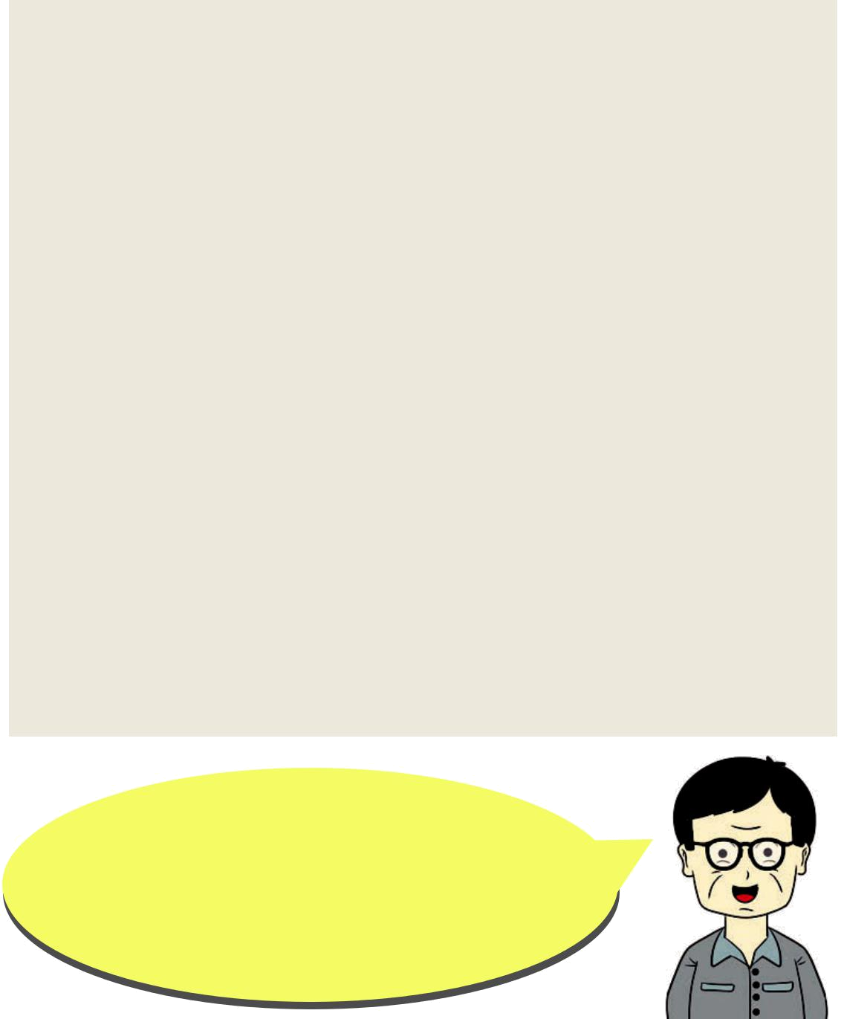
period gained new impetus, and was partly under the influence of Ottoman and European, and Chinese traditions.
Iranian pottery also has white (gombroon) wares. The term "Gombroon" derives from the old name of modern Bander Abbas, which in Safavid times was an important port on the Persian Gulf. The "Gombroon" ware has a hard faience body, which is considerably thinner than that of contemporary lustre ware. As often described, lustre ware has a very hard and compact white body and was decorated in golden, brownish or reddish colour. Gombroon ware is occasionally even translucent.

Through the centuries, Persian potters have adopted and refined newly introduced forms and blended them into their own culture. (This article is adapted from three Internet sources:

http://www.merriam-webster.com/dictionary/pottery, http://en.wikipedia. org/wiki/Persian_pottery,and http://www.cais-soas.com/CAIS/Art/iranian _pottery.htm)

When reading the text, what questions come up in your mind? Write the questions in the space below, then work in pairs and ask your friends using the questions you have written.

…………………………………………………………………………………………

…………………………………………………………………………………………

…………………………………………………………………………………………

…………………………………………………………………………………………

- Kelas XII SMA/MA/SMK/MAK

………………………………………………………………………………………….

…………………………………………………………………………………............

………………………………………………………………………………………….

.…………………………………………………………………………………………

………………………………………………………………………………………….

.…………………………………………………………………………………………

………………………………………………………………………..........................

Vocabulary Builder

Task 2: Write down the synonyms of the following words.

faience (n) : ____________________

glaze (n) :____________________

scroll (n) : ____________________

lustre (n) : ____________________

depict : ____________________

vessel (n) : ____________________

impetus (n) : ____________________

Pronunciation Practice

Task 3: Listen to your teacher reading these words. Repeat after him/her.

w a r e : /wɛr/

p o l y c h r o m e : /ˈ pɑˌ liˌ kroʊm/

p o r c e l a i n : /ˈ pɔrsələn/

g l a z e : /gleɪz/

s c r o l l : /skroʊl/

l a n d s c a p e s : /ˈ lændˌ skeɪps/

d e p i c t : /dɪˈ pɪkt/

t r a n s l u c e n t : /trænˈ slusənt/

v e s s e l : /ˈ vɛsəl/

i m p e t u s : /ˈ ɪmpətəs/

m o m e n t u m : /moʊˈ mɛntəm/

Bahasa Inggris | 137

C. COLLECTING INFORMATION


Read the following conversation about pottery products in Malang and practice the conversation with your friends.


Benny and Ana are two senior high school students in Malang, East Java. They are talking about pottery products in Bethek, a pottery-manufacturing area in Malang.

Beny : Hi Ana, I heard you visited ceramic village in Bethek last week. Is it true?

Ana : Yes, you’re right.

Beny : Anything interesting?

Ana : It was the first time for me to visit the pottery-manufacturing area. I was surprised that there were more that 10 ceramic factories in Bethek. You know Bethek is not a large area, but …

Beny : Do they have any association?

Ana : No, they are kind of traditional manufacturers. They have a good potentials actually. Their products show a high level of creativity.

Beny : I see.

Ana : I think the government needs to help them improve their quality by setting up an association for the producers and the artists.

Beny : You're right. The association can also help them market their products to other places,

- Kelas XII SMA/MA/SMK/MAK


not only in Malang area.

Ana : You’re right. They might even sell their products to overseas market.

Benny : Alright, let’s think of how we can help them

Ikhsan : Atim, do you know how to make ceramic products?

Atim : Yes, first mix the materials.

Ikhsan : What are the materials?

Atim : Kaolin, felspard, kwarsa and ball clay. Mix them with water.

Ikhsan : What’s next?

Atim : Filtering. The mixture must be filtered to get the smooth material.

Ikhsan : I see. And then they form it?

Atim : Yes, correct. They do it by pouring the mixture in a cast, let it stand until it dries.

Ikhsan : Then…

Atim : The next step is firing in 1.220 degrees celcius. It takes 10 hours for firing and 24 hours for cooling down.

Ikhsan : Wow, it’s a long process.

Atim : The last step is decorating. Here, the artists draw different kinds of pictures depending on the customer’s order or their own creation.

D. ASSOCIATING

Text Structure


Now, let’s understand the text structure. Then, fill in the blanks by referring to the text about Persian Pottery.


Bahasa Inggris | 139

Observe the text structure.

The text about ‘Persian Pottery’ above is called a factual report (information report). The first paragraph of the model text gives us some general information about Persian pottery which includes a classification of it. All the paragraphs that follow the first paragraph contain some description about Persian pottery; they contain some detailed features of the things being described.

Read the text again, and then write in the table below the appropriate information about Persian pottery that the paragraphs deal with.


Introductory

Paragraph

Supporting

Paragraph 1

Supporting

Paragraph 2

Supporting

Paragraph 3

Supporting

Paragraph 4

Concluding

Paragraph

- Kelas XII SMA/MA/SMK/MAK

Grammar Review
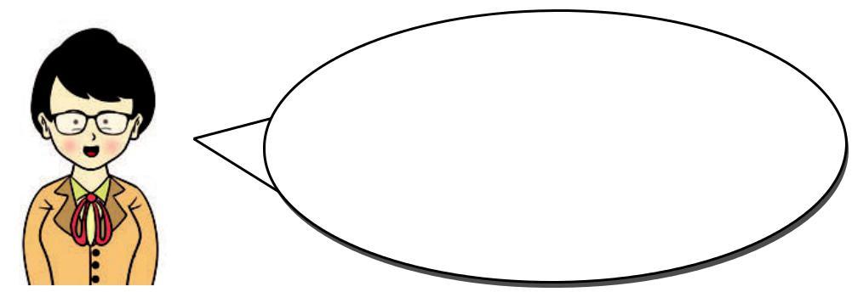

Now, let's focus on grammar. Pay

attention to the reading text above.

What can you learn from that?

Verbs often used to describe the pottery are: be, have, look, appear, and so on. Some of the descriptions are written in Simple Present Tense and some are in Simple Past Tense. Write down the sentences which contain verbs in the simple past tense and present tense in the table below.
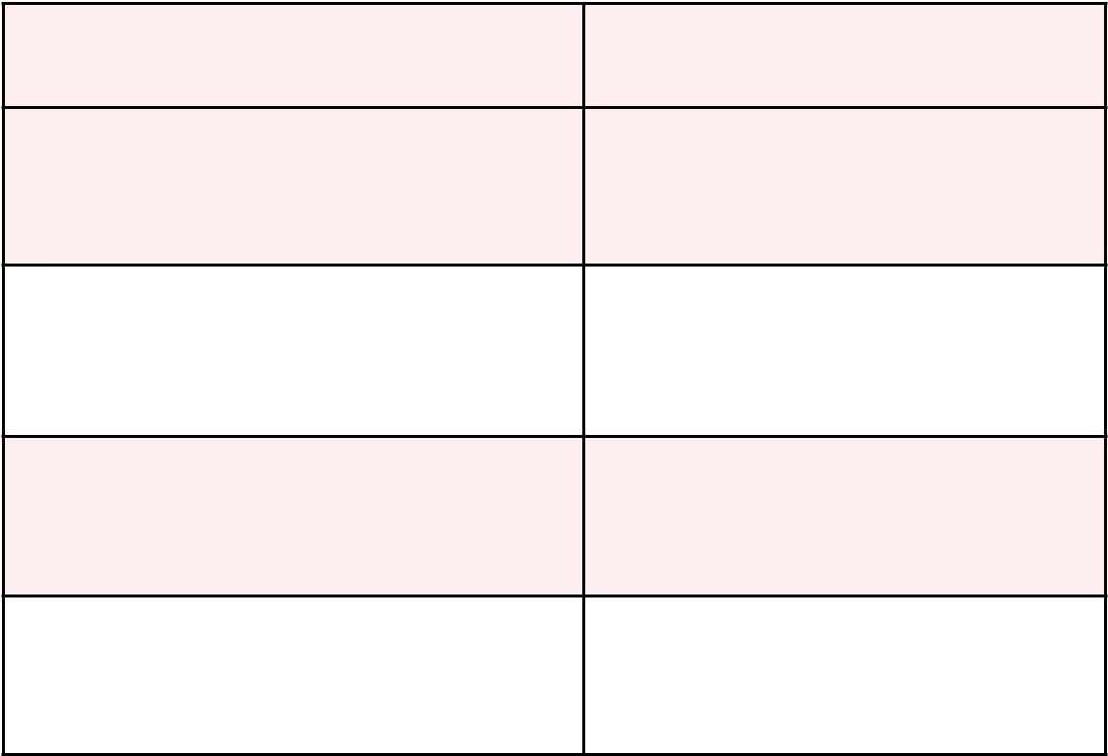

Simple Present Tense | Simple Past Tense

Pottery is one of the oldest
The Arab empire was one of
and most widespread of the
the strongest.

decorative arts.

Bahasa Inggris | 141

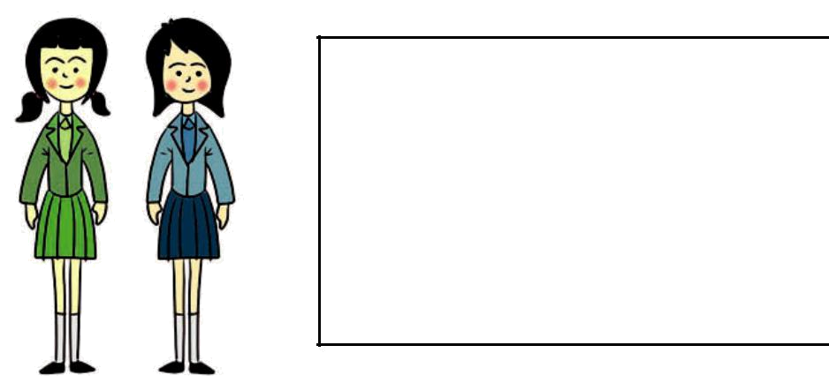
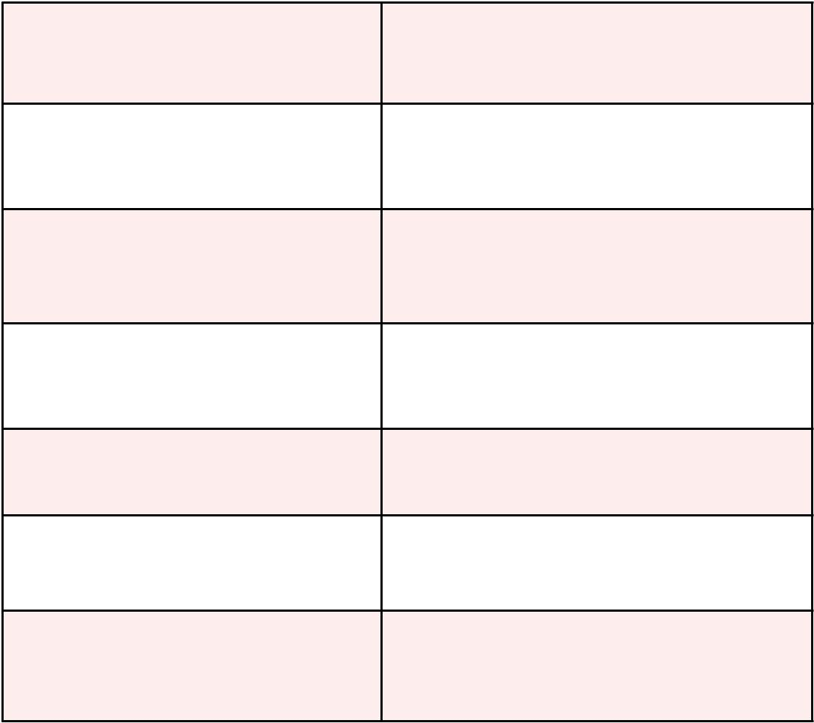

Discuss this phenomenon in a group of 5; each of you will be a mayor, a worker, the owner, a student, and a customer. Think of pros and cons.

- Kelas XII SMA/MA/SMK/MAK



  - Observe pottery workshops in your area. If there’s no such manufacturer, you can observe other product manufacturers. Prepare to report the results of your observation to your friends. Start by generating ideas, then make an outline, and finally write the factual report.

- COMMUNICATING

Speaking : Group Discussion

Task 1:
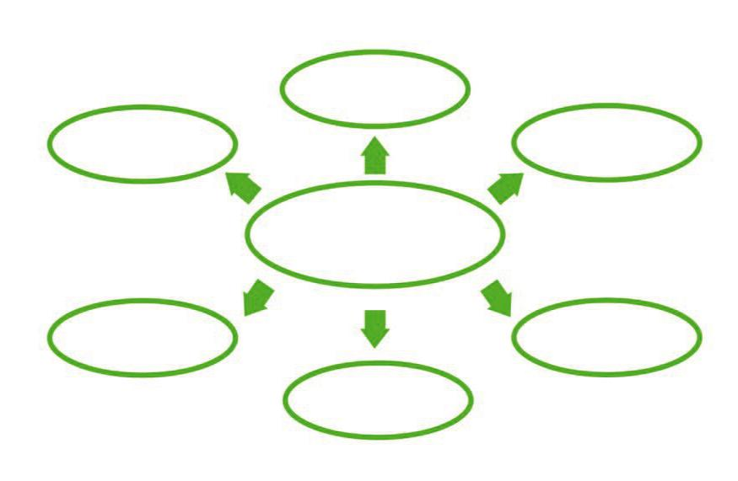

Task 1:

(Text)

(Text)

Ceramic

Write down whatever comes up to your mind in the following mind-map. You can add with more points and sub-points.

(Text)

Bahasa Inggris 143

Task 2: Write down an outline of your essay. You can add more supporting paragraphs as necessary.

Introductory paragraph:

…………………………………………………………………………………….

…………………….………….……………………………………....................

(write down your subheading).

Supporting paragraph 1:

…………………………………………………………………………………….

…………………….………….……………………………………....................

(write down your subheading).

Supporting paragraph 2:

…………………………………………………………………………………….

…………………….………….……………………………………....................

(write down your subheading).

Supporting paragraph 3:

…………………………………………………………………………………….

…………………….………….……………………………………....................

(write down your subheading).

Supporting paragraph 4:

…………………………………………………………………………………….

…………………….………….…………………………………........................

(write down your subheading).

Supporting paragraph 5:

…………………………………………………………………………………….

…………………….………….…………………………………........................

(write down your subheading).

- Kelas XII SMA/MA/SMK/MAK

Concluding paragraph:

……………………………………………………………………………………

…………………….………….…………………………………………………..

(write down your subheading).

Task 3: Develop your outline into a good factual report. Use more space if needed.



……………………………………………………………………………………………………………

……………………………………………………………………………………………………………

……………………………………………………………………………………………………………

……………………………………………………………………………………………………………

……………………………………………………………………………………………………………

……………………………………………………………………………………………………………

……………………………………………………………………………………………………………

Peer feedback

Exchange your writing with your friends. Ask your friends to give feedback to your writing and give feedback to your friend’s writing. Your teacher will guide you how to give feedback.

Rewriting

Based on the feedback given by your friends, rewrite your essay.

R E F L E C T I O N


Do you know how to create a factual report? Respond to these questions to check whether you understand how to create a factual report about natural phenomena.

Source: www.123trf.com

- Do you use general information to introduce your topic

- Do you give necessary description (specific features) using subheadings (history, location, appearance, and other information)?

- Do you use present verbs and past verbs?

- Do you pay attention to spelling, punctuation, capitalization, and formatting?


- Kelas XII SMA/MA/SMK/MAK

